Exercise No 5: Information gathering using theHarvester

Aim: To demonstrate information gathering using theHarvester

Procedure:

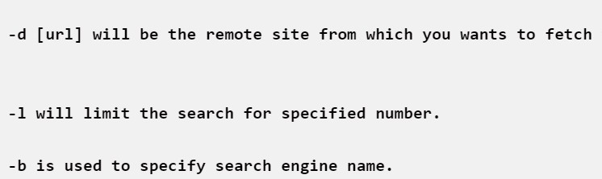**STEP 1: Open Terminal in the kali linux**

**STEP 2: Run the following command**

**Command: theHarvester -d** arms.sse.saveetha.com**-l 300 -b all**

**Step 4: run this command “theHarvester -d arms.sse.saveetha.com -l 300 -b all -f test” and hit enter to export the result as html file and xml file**

**Step 5: now close the terminal and navigate the home folder and search**

**OUTPUT**

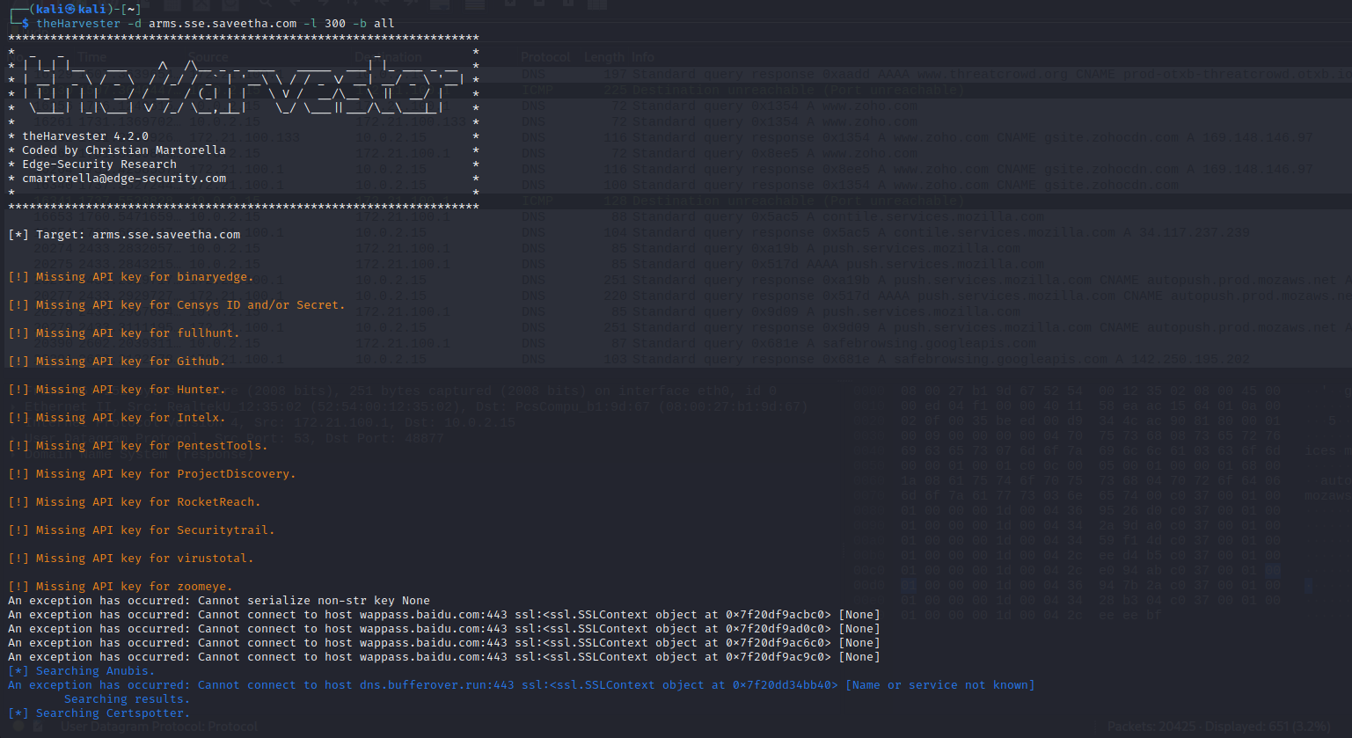

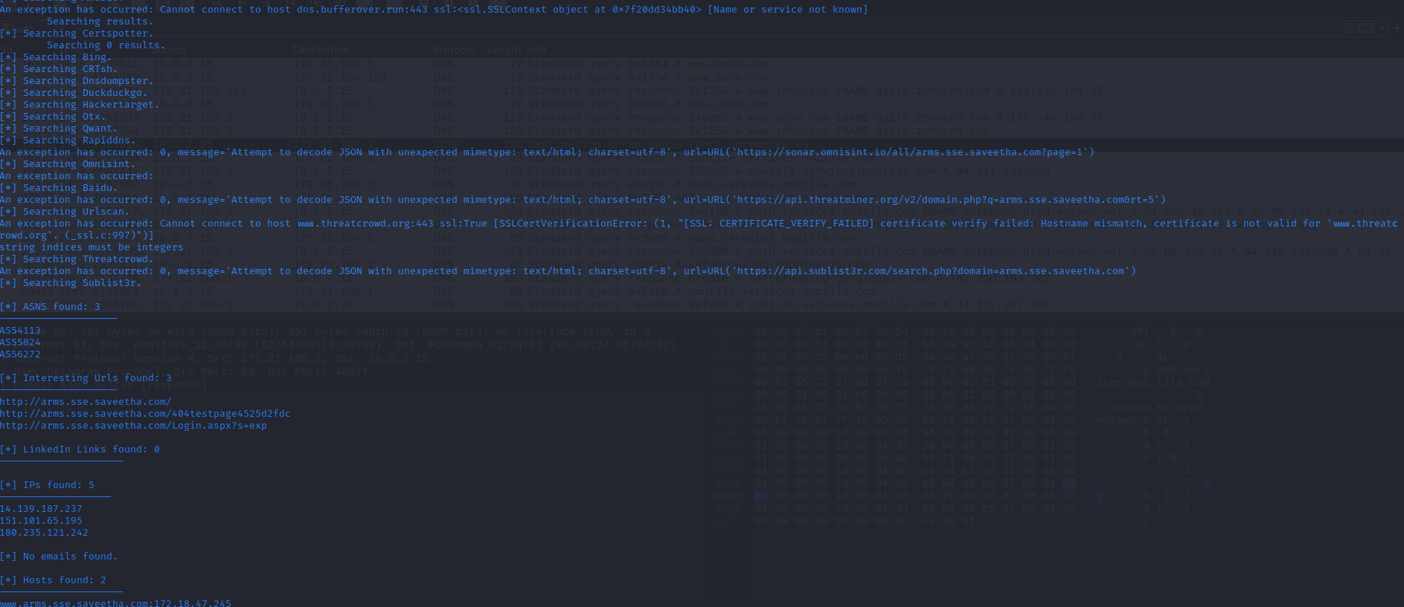

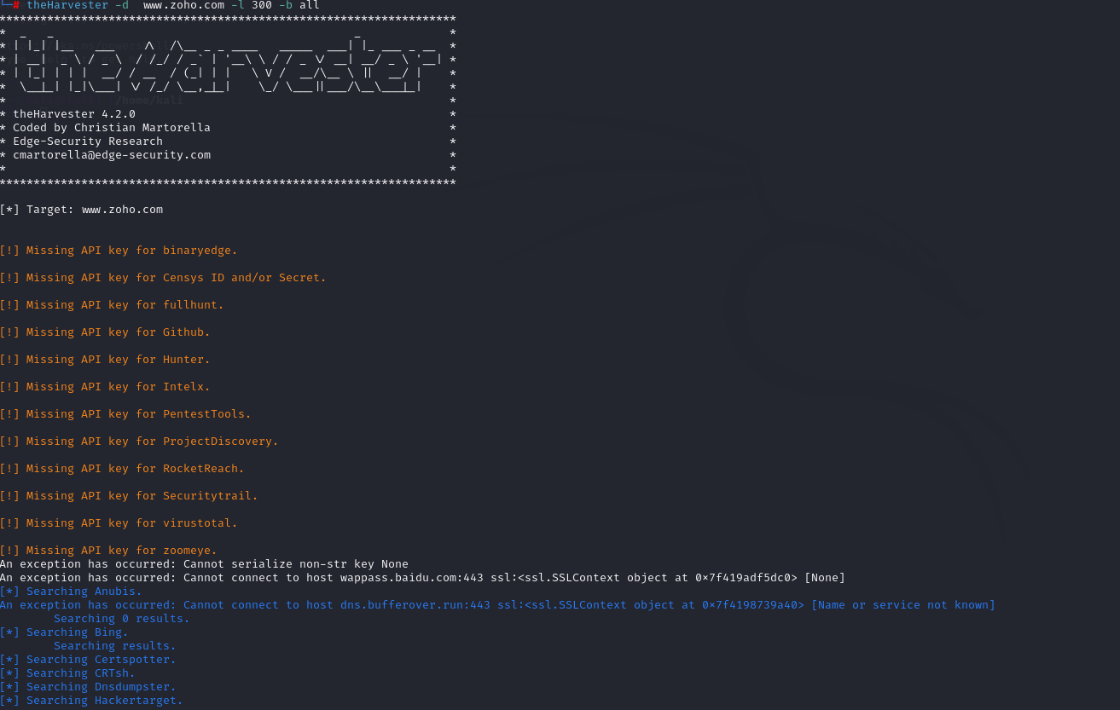

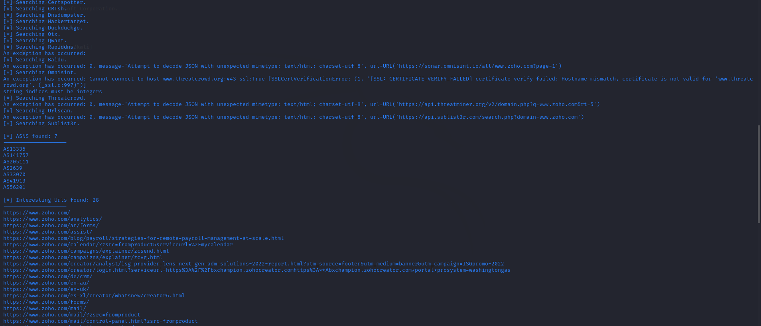

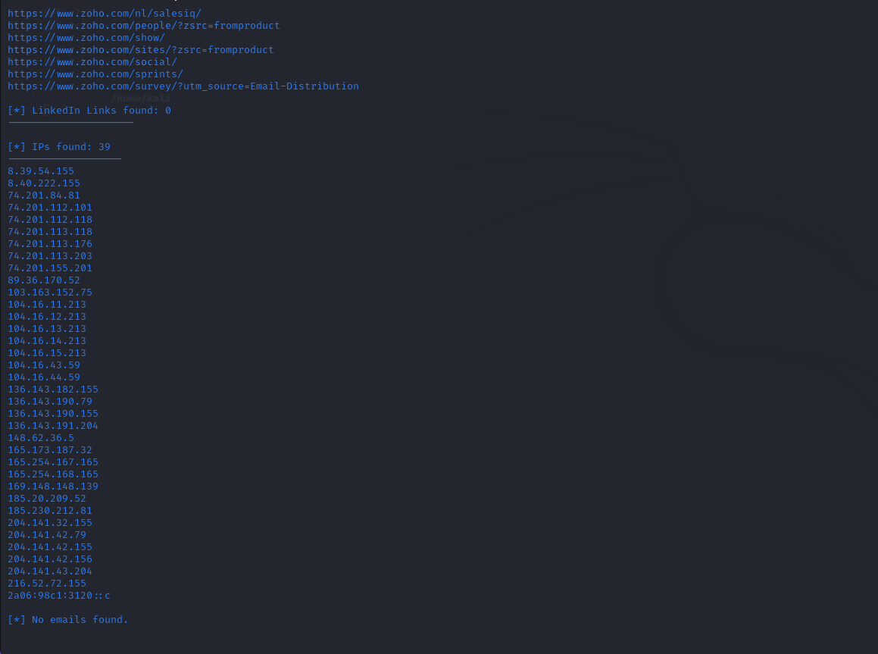

**Result**

Information gathering using theHarvester is performed successfully.